# Jonathan Jimenez

# Assignment 2: IA Critique

## Point Value: 15

## Related Student Learning Outcomes: 1, 3, 6

What/Where to Submit: A typed document submitted to the assignment submission area of the IA Awareness Assignment on Canvas

Due Date: October 24, 2021 at 11:59 p.m. Eastern

## Assignment Instructions:

Now that you have chosen your project website, you will want to look at other websites in the same industry to possibly get ideas for improvements.

Do the following:

1. Find two websites of competing/comparative companies or organizations.

Clay County School District - <https://www.clay.k12.ky.us/>

Perry County School District - <https://www.perry.kyschools.us/>

1. Provide screenshots of their home pages (entire page – it may require stitching some screenshots together).

Perry County Schools

Clay County Schools

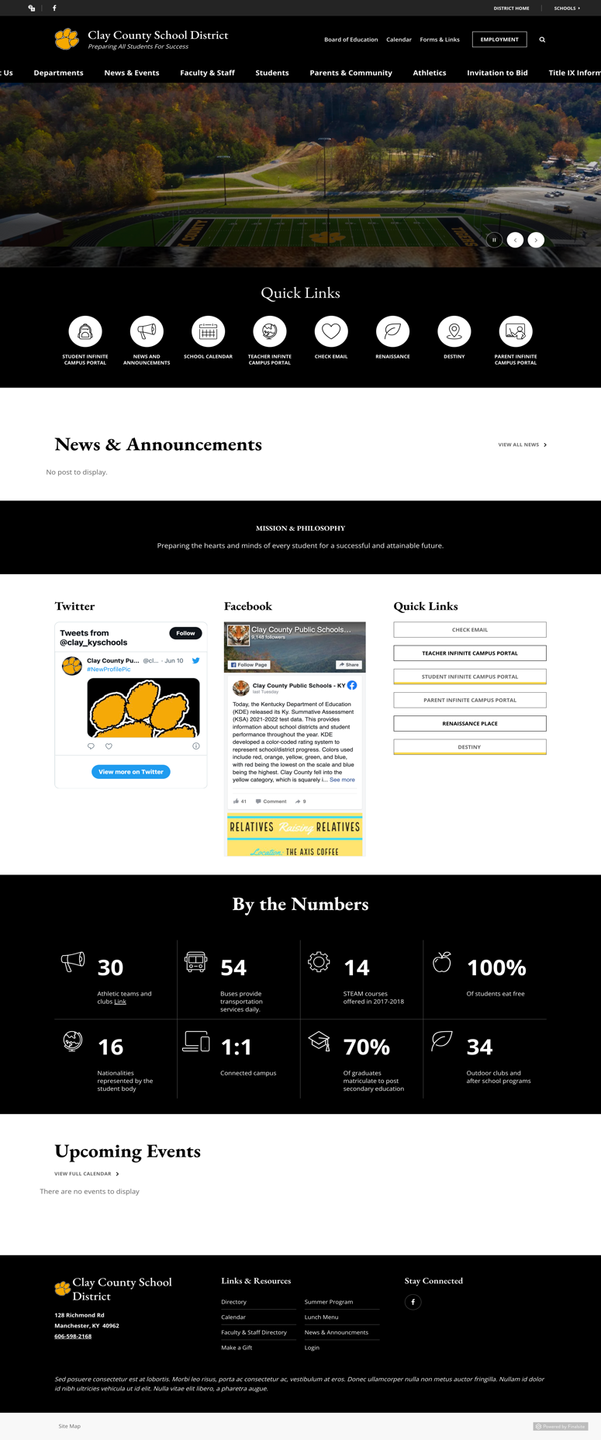

1. Compare the organization, labeling, navigation, and search systems. Whose do you like better? Why?

|  |  |  |  |
| --- | --- | --- | --- |
|  | Perry County Schools | Clay County Schools | Verdict |
| Organization | The site was organized in a hierarchical fashion that was broad and shallow. It could only go through about two subpages within itself. While some information is shown on the home page, most of the "meat and potatoes" are not until you click the one of 4 options within the navigation system, another will appear. | The Clay County Schools site is organized in a hieratical fashion that has a little more complexity in terms of depth of subpages, but not by much. While it may seem more complex and intuitive, in fact, most of the extra pages are unneeded. For example, when you select a department, a list will show up with all the contact info. If the user were to click the department, only the name of the director would appear and not the contact info that was shown previously. | |  |  | | --- | --- | | |  | | --- | | The winner of the organizational section is Clay County Schools. While there were unnecessary pages that spread the information thin, the way in which it was separated into sections made it easy to navigate and understand. In Perry County Schools' case, users could jump around the site with no structure. In one moment, you are reading the faculty, then in one click you are reading the lunch menu. | | |
| Labeling | The labeling system is not bad, but it could use some work. For example, one of the options in the navigational system states "calendar." If I did not know this was connected to the school district, I would be confused as to what it’s scheduled for. Because the site's primary goal is to educate students, the labels can be understood in relation to the schools. | The Clay County Schools labels get to the point but could use some more clarification. If I didn’t know as a user that the website was connected to schools, I would be confused as to where a "click" would take me. For example, the options available state "news and events", but of what? The labels in the quick link are far more leading than others, as it states, "school calendar", clearly indicating what it is indented for (schools). | In my opinion, both systems could use some work, but Clay County District would be the winner here, as in some options (not many), the site specifies what the section is talking about. For example, instead of saying just calendar its said “school calendar”. |
| Navigation | The global navigational tool is clear and usable when on the home page. Although 4 of the options given lead to another page that has another navigational tool organized in a topical fashion. The only way to access the "second navigational tool" is to click on one of the four, which are district news, about PCSD, staff directory, and superintendent message. The second navigational tool also does not follow a strict hieratical fashion as "District News" and "District Events" could be organized in a different manner, improving efficiency overall. | The Clay County School District global navigational tool is organized in a topical scheme where sub-information relating to the section can be seen once the mouse is hovering over the target. One major problem that I encountered while utilizing this function was that the whole navigational tool on the site did not fit the screen. The words that are at the ends are cropped out. Instead of seeing "about us", the user would see "us". | The Clay County District is the winner as it does not have two navigational tools. Accessing the Clay County navigational tool was simple and easy as it was located at the top of each page. On the Perry County site, an option to the home page had to be clicked to see the second one. This just seems like an unnecessary step that could easily frustrate users. |
| Search System | When working with the Perry search tool, I was a little confused at first as it did not look like standard. When I searched for a key word, a popup box would appear with Google search results related to Perry County Schools. This caught me off guard as I was expecting results from the site itself, not Google. After doing a little digging, I discovered that the search tool stated it was "enhanced by Google". | The search tool that was provided by Clay County Schools looked familiar and easy to use when I first looked at it. The design in which it was formatted seemed standard. After searching for a keyword, it returned a list of results that had the keyword present within them. The user could then narrow down the search and select what he/she needs. | The winner is Clay County District as the search tool seems simple, standard, and reliable. When I was looking at Clay’s search bar, it returned results within its own site. In Perry County’s case, it would pop up a separate window with Google results. In any scenario that seems "fishy," it is best to not click. When looking at the pop-up results, users could feel uncomfortable. effectively scaring them away from the site. |
| Notes |  |  |  |

## Assignment checklist/rubrics:

Provide screenshots of the home pages of two competing/comparative companies or organizations. = 3 points

Compare organization systems, declare winner(s), and explain why. = 3 points

Compare labeling systems, declare winner(s), and explain why. = 3 points

Compare navigation systems, declare winner(s), and explain why. = 3 points

Compare search systems, declare winner(s), and explain why. = 3 points

Total = 15 points